Revolutionizing Social Media Security: Unleashing the Potential of Federated Learning in Industry, Innovation, and Infrastructure

Dr. Shafaq Khan  
*School of Computer Science*  
*University of Windsor*  
Windsor, Canada  
shafaq.khan@uwindsor.ca

Sai Renuka Telu  
*Master of Applied Computing  
University of Windsor*Windsor, Canada  
telu@uwindsor.ca

Kavya Seeramsetty  
*Master of Applied Computing*  
*University of Windsor* Windsor, Canada  
seerams@uwindsor.ca

Neya Babu Thayyil   
*Master of Applied Computing  
University of Windsor*Windsor, Canada  
babutha@uwindsor.ca

Veera Venkata Satya Divya Pedapati  
*Master of Applied Computing  
University of Windsor*Windsor, Canada  
pedapatv@uwindsor.ca

***Abstract*—** **Big data is an invaluable tool for storing and managing complex data sets, which is vital for addressing various challenges in different sectors. However, with the continuous growth of big data, especially from one of the diverse sources like social media applications, the importance of privacy to security regulations has become increasingly crucial. To tackle these data privacy concerns, federated learning has been proposed as a method to enable collaborative AI model training. Traditionally, data from mobile users would be transferred to a central cloud for training machine learning models to extract insights from social media posts. This approach, however, exposes users’ sensitive information, such as preferences and location. Federated learning offers a solution by enabling ML model training directly on users' mobile devices, preserving privacy, optimizing resources. This paper reviews federated learning in social networks, emphasizing user data control, reduced risk, while addressing open challenges and future research directions.**

Keywords—federated learning, social media, model aggregation, privacy preserving, decentralized approach.

# Introduction

Security is vital in today's technology world since it protects a significant amount of data sets from each sector such as industry, innovation, and infrastructure. This paper investigates the application of federated learning in a privacy-conscious social media ecosystem to safeguard data from various domains. The rapid growth and widespread adoption of social media platforms have transformed the way people communicate, connect, and share information. Social media is the most vulnerable faculty on the internet due to its nature and amount of content it contains and the sensitive information it leverages makes it more vulnerable to attacks [1]. Traditional centralized systems to handling user data on social media platforms have shown vulnerabilities to data breaches, hacking attempts, and personal information misuse, all of which can have serious ramifications for individuals and society. To solve these issues, there is an immediate need to transform social media security by using the power of federated learning. Federated Learning is a decentralized machine learning approach that enables models to be trained across various devices or servers while keeping user data private and localized. The original federated learning requires model parameters, not raw training data sets, to be exchanged between multiple devices during the whole training process, which can greatly mitigate data privacy risks [2]. The motivation of this issue is to secure the users data using federated learning which concerns data privacy, security breaches and misuse of private information. Prominent examples are Google TFF, Open-Mined PySyft, define server and client roles and create privacy-preserving machine learning algorithms [3]. The objective of the paper describes “pioneering” this descriptor emphasizes the research's profound quality, since it takes a fresh and transformational approach to solving the critical concerns of social media security. Existing social media platforms frequently rely on centralized data storage and processing, which exposes them to targeted assaults, data breaches, and unauthorized access. The paper utilizes diverse datasets to study user behaviors, preferences, characteristics, sentiment, interests, social relationships, and content preferences, while ensuring data privacy through federated learning.

# Related Work

Researchers Mansoor Ali and Faisal Naeem proposed techniques using federated learning to improve AI system training with distributed devices, preserving privacy by keeping data local. They suggested using federated learning techniques, such as context-aware knowledge algorithms and data encryption, along with privacy protocols like PHE and TSS to prevent data leakage and ensure confidentiality. By adopting federated learning algorithms in distributed devices, the local model parameters are communicated while the host data remains within the local nodes. This increases privacy and reduces information leakage scenarios [4].

Research has discussed two federated learning approaches: centralized federated learning, where devices send local model parameters to a server for global model updates, and decentralized federated learning, where devices communicate peer-to-peer for parameter aggregation. In a decentralized federated learning system, all devices are connected over peer-to-peer communications. A device can transmit the model parameters, locally trained on its own dataset, to neighbors and receive their model updates to aggregate parameters [5]. Mainly, Chamikara and Bertok identified attack methods exploiting vulnerabilities of ML models and coordinating servers for data retrieval. They proposed a distributed perturbation algorithm named DISTPAB, for privacy preservation of horizontally partitioned data. DISTPAB alleviates computational bottlenecks by distributing the task of privacy preservation utilizing the asymmetry of resources of a distributed environment, which can have resource-constrained devices as well as high-performance computers [6].

In this paper, the focus is on preserving privacy in social media using a combination of federated learning and decentralized learning. Given the challenges posed by the vast and heterogeneous data in social media, privacy-preserving techniques like differential privacy and secure aggregation, are being implemented. The hybrid approach involves periodically aggregating model updates from devices to a centralized server for global optimization, aiming to protect user data in the federated learning system.

# Current Challenges in Social Media Data Privacy and Security

In the realm of social media applications, ensuring robust security measures has become a paramount concern. The below graph presents a depiction of the current state of security in such applications, with a focus on the vulnerable ways information breaches occur globally.

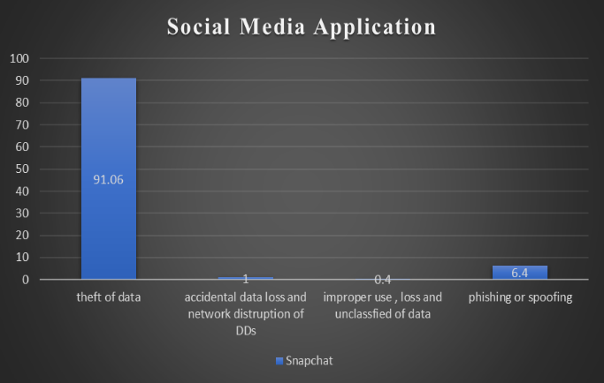

Fig. 1. Data breaches in social media applications.

As Fig. 1. illustrates the distribution of information breaches in social media applications worldwide from 2015 to 2023, several significant data breaches and security incidents have impacted social media platforms, including Facebook, Twitter, Snapchat, and Instagram, due to sharing raw data with cloud servers. In 2019, Facebook experienced a breach that exposed the personal data of approximately 540 million users, as user data was stored on publicly accessible Amazon Web Services (AWS) cloud servers by third-party app developers. Furthermore, Twitter faced a high-profile security incident in 2020, where several prominent accounts were compromised, leading to a cryptocurrency scam. These incidents highlight the risks associated with centralizing sensitive user information on cloud servers, underscoring the need for robust data security and privacy protection measures on these popular social media platforms.

TABLE I.

|  |  |  |
| --- | --- | --- |
| **Sno** | **Platform** | **Cyber attacks / data stolen** |
| 1 | Facebook | 540M users |
| 2 | Twitter | 4.6M users |
| 3 | Snapchat | 5.4M Users |
| 4 | Instagram | 4.9M Users |

Table I. illustrates the challenges of maintaining information privacy in real-time social media platforms, showcasing data breach incidents that have compromised user-generated data [7][8][9][10].

# Proposed study

Federated Learning allows mobile phones to collectively learn a common prediction model while preserving all training data on the devices themselves, separating the ability to perform machine learning from the necessity of storing data in the cloud. This goes beyond the use of local models that make predictions on mobile devices (like the Mobile Vision API and On-Device Smart Reply) by bringing model *training* to the device as well. Furthermore, because the global aggregator model acts as a learner in this scenario to acquire and label training datasets during federated learning, for instance at every communication cycle, it potentially impedes the convergence of the global aggregator model owing to the data sampling bias [11].

The idea proposed in this paper called “Privacy-Preserving User Profiling in social media using Federated Learning” introduces a novel methodology for user profile prediction, incorporating advanced machine learning algorithms such as Convolutional Neural Network (CNN). Instead of relying on a centralized server or cloud infrastructure for model training, the approach involves the distribution of a fundamental model, particularly the CNN, to individual client mobile devices. Subsequently, user data is utilized for local training and testing on their respective mobile devices. The locally trained CNN models are then transmitted back to a central server for global aggregation, culminating in the creation of a final comprehensive model. This decentralized process ensures that user profiles are predicted without compromising data privacy, as sensitive information remains securely stored locally. The innovative implementation of federated learning, complemented by CNN's powerful image-related tasks and pattern recognition capabilities, guarantees the generation of personalized recommendations and user profiles while upholding the highest standards of social media security and privacy protection.

## **Why** federated learning **is required**

Federated learning is required to address the limitations of centralized machine learning and harness the benefits of distributed machine learning. As shown in Fig. 2. centralized machine learning systems, while participants enjoy computational efficiency, their private data is at risk and communication overhead can be high. Distributed machine learning offers scalability but lacks a collaborative framework. Federated learning bridges these gaps by allowing models to be trained on decentralized devices without compromising data privacy.

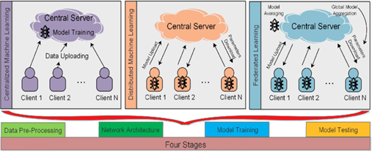

Fig. 2. Comparison of centralized, distributed, and federated systems [12].

## **How does Federated Learning work with respect to social media?**

Federated learning is a decentralized approach where models are trained on distributed devices without centralizing data. In Fig. 3. devices receive an initialized global model and update it using their local data. Only model updates, not raw data, are transmitted and aggregated on a central server to create an improved global model. In social media platforms, federated learning enables privacy-preserving user profiling and personalized content recommendations by performing local analysis on user devices, ensuring data privacy and confidentiality. This collaborative and secure process revolutionizes how social media platforms leverage user data while prioritizing privacy.

Fig. 3. Working mechanism of federated learning on local devices [13].

## Methodology

1. **Data Collection: -** Collection of user interactions, preferences, and behavior data on social media platforms. Social media platforms collect a vast array of data from users, encompassing their interactions, preferences, and behavior. These data points, such as likes, comments, and profile information, provide valuable insights that drive personalized experiences and targeted content. This data collection enables social media platforms to tailor their offerings to individual users and enhance user engagement.
2. **Local User Profiling: -** Analysis of user interactions, preferences, and behavior on individual devices to create user profiles. User profiles are constructed by synthesizing the user information, enabling a deeper understanding of individual users. Privacy-preserving techniques are employed to protect user data confidentiality during the profiling process. Through encryption, anonymization, and other measures, sensitive user information remains secure and inaccessible to unauthorized parties.
3. **Local Model Training**: - Training machine learning models on individual devices using locally profiled data enables personalized model development. Each device utilizes its own data to train a model that captures user preferences and characteristics specific to that device, ensuring data privacy and minimizing data transfers. This approach allows social media platforms to deliver tailored experiences and recommendations while upholding user privacy and data confidentiality.
4. **Model Update Transmission**: - Transmission of model updates from user devices to a central server. Model updates, containing information about performance and learning progress, are transmitted from user devices to a central server in federated learning. This allows the central server to receive the latest insights without compromising user privacy. By sending model updates instead of raw data, sensitive user information remains secure and confidential during the transmission process.
5. **Model Aggregation**: - Aggregation of received model updates on the central server. By aggregating the model updates, the central server can synthesize the information and identify patterns, trends, and improvements across the distributed models. This step enables the central server to create a more accurate and comprehensive representation of the collective knowledge contained within the individual models.
6. **Global Model Distribution:** - Distribution of the updated global model back to user devices. By distributing the model back to the user devices, social media platforms enable local devices to benefit from the collective intelligence and insights gathered from the entire user community.
7. **Local Model Refinement**: - Integration of the updated global model on user devices. This integration ensures that each device can benefit from the refined global model, enhancing the accuracy and effectiveness of local models for personalized experiences. Further refinement of local models based on aggregated knowledge, allowing adaptation and improvement. With the integrated global model, local models on user devices undergo further refinement based on the aggregated knowledge.
8. **Iterative Process**: - The iterative process in federated learning continues with the integration of updated local models on user devices, allowing for continuous improvement. Repetition of model update transmission, aggregation, and distribution to enable continuous learning. Fig. 4. helps in understanding the iterative process of the entire model trained using federated learning techniques.

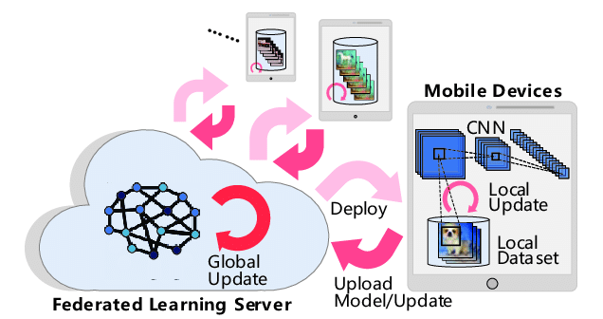

Fig. 4. Iterative workflow of the model [14].

## Designing a privacy-preserving user profiling system in social media using federated learning

## There is a need to start by preparing the data, anonymizing or pseudonymizing it to protect user privacy. Firstly, collect user-related data from the selected social media platform, ensuring compliance with data protection regulations followed by partitioning of the data using techniques like client-side hashing or encryption to safeguard sensitive information and maintain user anonymity. And then set up the federated learning infrastructure using TensorFlow Federated (TFF) framework. Lastly, aggregate locally trained models using techniques like federated averaging while preserving the privacy of individual user data. After evaluating the performance of the privacy-preserving user profiling model, using appropriate metrics will complete the process of designing the approach.

## Different types of datasets can be employed in the creation of a user profiling system that preserves privacy in social media using federated learning. User profile data includes demographics, interests, and self-reported attributes. Textual, network, and multimedia data offer insights into sentiment, relationships, and content preferences, with privacy compliance and consent being essential for user privacy. The substantial methods employed to analyze the data and extract valuable insights encompass both traditional machine learning algorithms like K-Means, CNN and KNN, however, applying CNN will benefit the model in this case.

## Fig. 5. Data analytics workflow.

## Proposed System Client-Server Architecture

The proposed system is built upon a robust client-server architecture as shown in Fig. 6. which facilitates seamless communication and data exchange between users and the central server. The architecture is designed to leverage the benefits of both client-side and server-side processing, ensuring efficient data management, privacy preservation, and personalized user experiences.

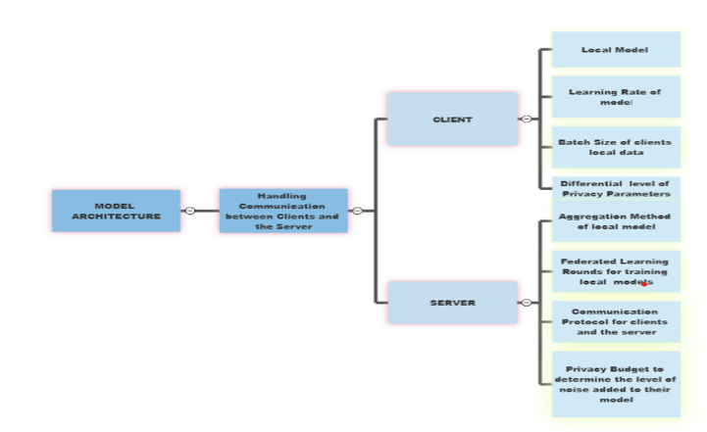

## Fig. 6. Proposed architecture for client-server interaction.

# Interpretation of the research

The proposed privacy-preserving user profiling system using federated learning in social media showcases promising outcomes in terms of data security, personalized recommendations, and user empowerment. The process starts with the distribution of an initialized global model to user mobile devices or individual servers.

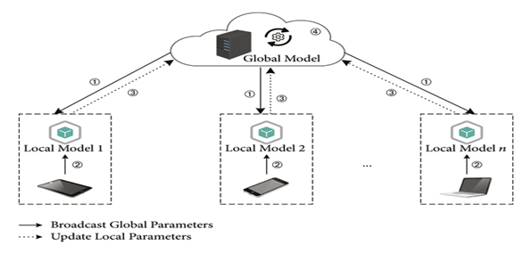

## Fig. 7. Distribution of initial model to local devices [15].

By providing a common starting point for all devices, this step ensures that the initial model's architecture and parameters are consistent across the network, setting the foundation for collaboration. Various ML algorithms (CNNs, RNNs, K-means) can be used for personalized user profiles. However, CNN is our preferred choice as it is well suited for image-related tasks and pattern recognition as shown in Fig. 8.

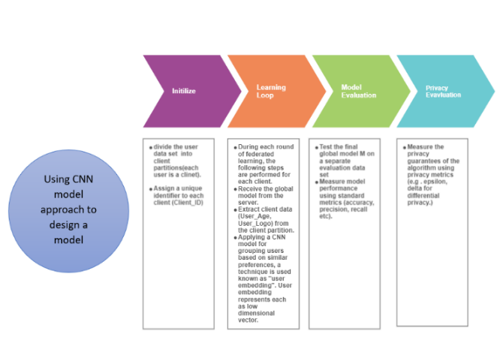

## Fig. 8. Workflow using convolutional neural network.

K-means, logistic regression, and CNN are all distinct algorithms with specific strengths. K-means is useful for unsupervised clustering tasks, while logistic regression is a linear model often employed for binary classification problems. On the other hand, CNN is a powerful deep learning architecture, particularly adept at image-related tasks and pattern recognition and it emerges as the most suitable choice. Therefore, its ability to extract intricate features from images and its success in computer vision tasks make it the best fit for the intended application.

## Fig. 9. Comparative analysis of convulutional neural network algorithm and alternative algorithms.

In the proposed system, model updates with performance information are sent to the server for aggregation using federated averaging. The global model represents collective knowledge as in Fig. 10., while preserving data privacy.

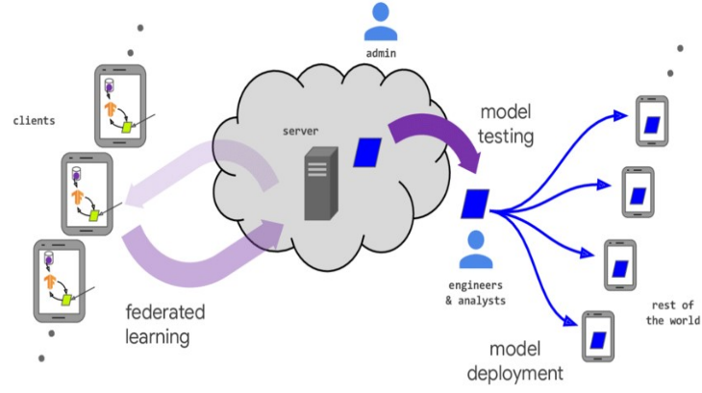

## Fig. 10. Model development phases - design to deployment[16].

## Overall, the analysis demonstrates that the proposed privacy-preserving user profiling system using federated learning represents a significant leap forward in data security, user experience, and privacy protection within the social media landscape. By leveraging the power of federated learning, the system strikes a balance between personalized recommendations and individual data privacy, setting new standards for a secure and user-centric social media ecosystem.

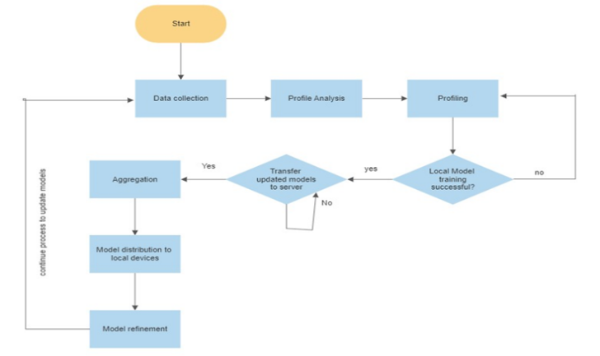

## Fig. 11. Model design and implementation flow.

# Experimentation Analysis

In this research paper, we present a self-generated dataset tailored specifically for a privacy-preserving user profiling system using federated learning in the context of social media. The dataset contains a comprehensive set of user attributes that are crucial for understanding user behavior and preferences in online platforms. The public attributes available for analysis and modeling include User_Name, User_Gender, User_Theme, User_Language, and User_Country. These attributes are non-sensitive and can be utilized to gain valuable insights into user interactions and engagement on social media.

On the other hand, the dataset contains private attributes that require special consideration to maintain user confidentiality. These private attributes include User_Age, User_Interests, and User_Preference. Revealing this information publicly could lead to potential privacy violations and misuse of user data. By distinguishing between public and private attributes, we ensure that user anonymity is maintained while enabling valuable analysis and modeling of user behaviour. The target variable of interest in this dataset is User_Logo. By predicting the User_Logo attribute, we aim to create personalized user profiles while safeguarding sensitive information. Federated learning enables us to train machine learning models across multiple decentralized devices or platforms without centrally aggregating the data, thereby preserving user privacy.

## Global Model Initialization and Differential Privacy Setup

In the proposed privacy-preserving user profiling system using federated learning for social media, we begin by initializing the global model M, shown in Fig. 12., which serves as the foundation for collaborative training across decentralized devices. The global model is constructed based on a chosen machine learning architecture, such as a convolutional neural network (CNN), to capture complex patterns in the user attributes. The model's parameters, including weights and biases, are set to initial values before distributing it to the client devices (users' mobile phones) for local training. This initialization ensures consistency across all participating clients and lays the groundwork for aggregating their contributions securely. This dataset has a close distribution to the data generated by real edge devices. Then the edge server can initialize a global model M on the global dataset. For instance, Google uses the data collected previously from real users to initialize the word prediction model of Google Keyboard [17]. Differential privacy involves introducing controlled random noise to the data to protect individual user privacy. One critical aspect is managing the privacy budget, represented by the parameter epsilon (ε). Researcher named K. Wei et al. proposed a new user-level differential privacy algorithm, finds an optimal number of communication rounds for a given level of privacy and designs communication rounds discounting (CRD) methods to better balance complexity and convergence [18].

Global model initialization is as follows

M = Model() (1)

Forward pass of the model is defined using relu function and softmax function.

H = relu(W1 * X + b1) (2)

Softmax function for global model is

Y=Softmax(W2 * H + b2) (3)

Differential privacy setup

sensitivity=max(abs(gradient)) (4)

Where in (1) M is the model reference after defining and distributing the consistent global model to all the clients use relu and softmax functions as shown in (2) and (3) where in (2) H is the output of the hidden layer, W is the weight matrix that connects input features X to the hidden layer H, and b1 is the biased vector added to the weighted sum of W1 * X before applying relu activation function.

In (3) Y represents predicted output of the neural network which also known as logits or scores before applying softmax activation. Where W2 is the weight matrix that connects hidden layer H to the output layer Y, and b2 is the biased vector added to the weighted sum of W2 * H.

Where Sensitivity in (4) refers to the maximum absolute value of the gradients of a particular function with respect to its inputs. Moreover, epsilon is the constant value used for numerical stability and controlling the size of perturbations applied to the input. And at last b is calculated which is known as budget or perturbation budget.

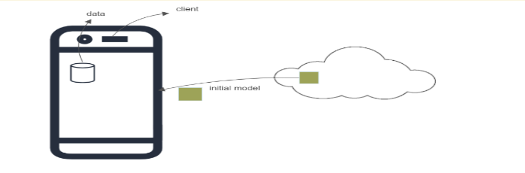

## Fig. 12. Federated learning initial model distribution.

## Data Distribution among Clients

Federated learning is extremely useful in building ML models where data is shared across different domains [19]. This plays a crucial role in dividing the dataset into equal-sized partitions, ensuring that each partition corresponds to a unique client based on their Client_ID. The function creates non-overlapping partitions of the dataset, where each partition represents a subset of user data belonging to a specific client (user) identified by their unique Client_ID. These partitions are of equal size, ensuring fair and balanced data distribution among clients. By using the Client_ID, the function assigns the corresponding data points to their respective client partitions in Fig. 13., ensuring that each client exclusively accesses their own data during local training.

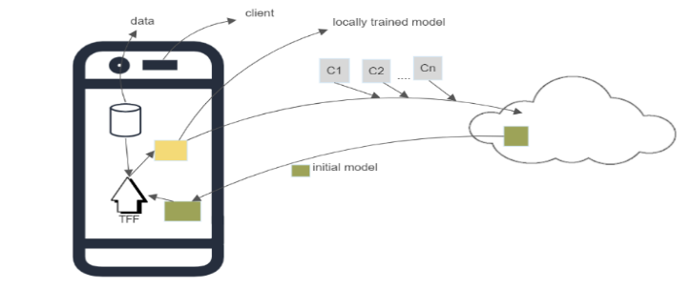

## Fig. 13. Federated learning with tensorflow initial model distribution among various clients.

## Federated Learning Loop

The federated learning loop is a fundamental iterative process that facilitates collaborative model training across multiple client devices while preserving user privacy.

* Local Model Training:During each round of federated learning the federated learning system iterates over all clients, which are the users' mobile devices participating in the collaborative model training process. For every client, a local model is trained using the received global model (M) as a starting point and the client's data extracted from their respective client partition. This decentralized approach ensures that sensitive user data, including attributes such as User_Name, User_Age, User_Theme, User_Logo, and User_Preference, remains securely stored on the client's device and is not shared with the central server or other clients. The local model training takes place autonomously on each client's device, allowing them to leverage their own data for personalized model updates while preserving data privacy. This paradigm empowers users to actively contribute to the model's improvement without compromising their confidential information, making federated learning an effective and privacy-conscious solution for collaborative model training in social media applications.
* Differential Privacy Noise:Differential privacy noise plays a crucial role in the federated learning system, safeguarding user privacy while updating the model. Before transmitting local model updates back to the central server, the system adds differential privacy noise to sensitive attributes, including User_Name, User_Age, User_Theme, User_Logo, and User_Preference, effectively obfuscating individual user data contributions. This privacy-preserving technique ensures that personal information and user preferences contained in the model updates remain protected and inaccessible to unauthorized entities. Attackers might retrieve the data information through the gradient, a DP preserved learning model could protect such information leakage in the Federated Learning setting [17]. Therefore, the level of noise added to the model updates is controlled by the privacy budget (epsilon), enabling a fine balance between preserving user privacy and maintaining the overall model's accuracy and performance.

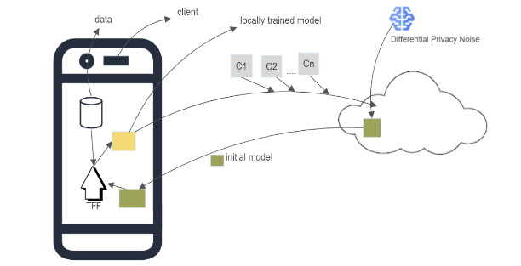

## Fig. 14. Federated learning with tensorflow local model training with differential privacy mechnanism.

* Federated Averaging:During the federated learning loop, individual client devices, representing social media users' mobile phones, perform local model training using their respective data partitions containing attributes such as User_Name, User_Age, User_Theme, User_Logo, and User_Preference. After the local model training is completed on each client, the locally trained models are transmitted back to the central server. At the central server, federated averaging takes place, where the model parameters from the locally trained models received from different clients are averaged. By calculating the average of the model parameters, the global model is updated to incorporate the knowledge learned from all participating social media users. This collaborative approach enables the global model to continuously improve its predictive capabilities over multiple rounds of federated learning.

θ_global(t+1) = (1/n) * ∑[i=1 to n] θ_local(i, t) (5)

where in (5)

* θ_global(t+1) represents the updated global model parameters after the (t+1) round of federated learning.
* n is the total number of client devices participating in the federated learning process.
* θ_local (i, t) refers to the model parameters of the local model trained on the ith client during the tth round of federated learning.

In this formula, the global model is updated by taking the average of the model parameters from the locally trained models received from different clients. This averaging process allows the global model to incorporate the knowledge learned from all participating clients, leading to a collaborative and privacy-preserving approach for user profile prediction in social media applications.

One of the key advantages of federated averaging in the social media context is its privacy-preserving nature. Since the central server never directly accesses individual user data, user privacy is maintained throughout the federated learning process. This ensures that sensitive information, such as User_Age, User_Interests, and User_Preference, remains securely stored on users' mobile devices and is not shared with the central server or other clients. By combining the power of federated averaging with the decentralized nature of the federated learning approach, social media platforms can deliver personalized and accurate user profile predictions while upholding the confidentiality of user data, making it an effective and privacy-conscious solution for user profiling in social media applications. Implementing federated learning for social media user profile preservation, the framework called "TFF" (TensorFlow Federated) plays a pivotal role. TFF enables the development and execution of federated learning algorithms specifically tailored for decentralized machine learning scenarios in social media applications. With TFF, the federated learning process can be extended to users' mobile devices, ensuring that user data, such as User_Name, User_Age, User_Theme, User_Logo, and User_Preference, remains locally stored and protected. TFF empowers the collaborative training of machine learning models across multiple devices without centralizing data on a cloud server as shown in Fig. 14., thus preserving user privacy in social media platforms. The framework provides essential tools and abstractions to efficiently implement federated learning algorithms, such as federated averaging, ensuring that the final global model's performance is rigorously assessed on a separate evaluation dataset. By utilizing the TFF framework, the federated learning approach becomes a powerful and privacy-conscious solution for personalized user profile prediction and preservation in social media applications.

# Boundaries of the Proposed Idea

## Communication Overhead:

## In federated learning, communication is a key bottleneck. In fact, a federated network may consist of a multitude of devices, such as millions of remote mobile devices. A training of a federated learning model may involve a large amount of communication [20]. In social media platforms with a vast number of users and constant interactions, this communication overhead can be significant and may lead to delays in model updates.

## Heterogeneous Data Distribution:

The capability to store, compute and communicate using the devices being part of federated network vary significantly from one another. The reason behind such differences is related to hardware, network connection and power supply [5]. Social media platforms generate diverse and unstructured data from different users. If the data distribution across users is highly imbalanced or inconsistent, the global model's performance may suffer, as certain user segments may be underrepresented in the training process.

## Limited Model Capacity:

Federated learning typically operates with limited model capacity due to the constraints of user devices. This limitation may restrict the complexity and size of the model, affecting its ability to capture complex patterns and make accurate predictions.

## Infrastructure Compatibility:

Federated learning may require modifications to existing social media infrastructure to accommodate the distributed learning process, potentially leading to additional implementation challenges and costs.

## Data Labeling Challenges:

## In social media, obtaining high-quality labeled data for supervised learning tasks can be difficult and costly. Federated learning relies on local devices to generate labels, which may lead to noisy or inconsistent annotations, impacting the overall model's performance.

## User Participation Bias:

The success of federated learning depends on user participation. If a significant portion of users chooses not to participate, the training data might be skewed, leading to biased model updates and reduced representativeness of the global model.

The limitations mentioned above arise due to the decentralized and collaborative nature of federated learning. The reliance on diverse user devices, data distributions, and the need for privacy preservation introduce unique challenges. Moreover, the challenges related to data labelling and user participation bias stem from the voluntary nature of user involvement. Not all users participate or provide high quality labels, impacting the overall model’s quality and generalization.

# Merits Of The Suggested Solution

* Data Privacy and Security: Federated learning allows devices to train models with their datasets locally and transfer model parameters to the server for aggregation [5]. As a result, sensitive user information is protected, reducing the risk of data breaches and unauthorized access. Users have more control over their data, leading to increased trust and privacy in social media interactions.
* Decentralized Training:With federated learning, participating agents train the model while relying only on their own resources and without sharing all the model parameters with a single agent [21]. This decentralized approach enables data processing without the need to share raw data, addressing concerns about data ownership and privacy in social media platforms.
* Federated learning enables efficient training on diverse social media data without centralization, improving generalization and user insights. It fosters personalized content recommendations by training local models on individual devices. Additionally, it facilitates regulatory compliance as user data remains local, aligning with privacy laws.

## Fig. 15. Positive aspects of federated learning.

# Implications and Further Research

To implement our idea, we have gone through several ML algorithms like CNNs, RNNs, K-means to do local model training among those we have chosen CNN as it captures intricate patterns and features within images and can be used in various image related tasks. Federated Averaging ensure privacy preserving, data diversity, scalability, regulatory compliance, reduction in communication overhead and collaborative learning. Social media platforms may share user data with third-party companies for various reasons which may results in data breaches, cyberattacks and privacy concerns. Through ML, we can achieve privacy, but data is processed only in centralized systems and entire data is shared to central server where it fails to maintain privacy, as social media data is very vast, Federated learning ensures the collect and process data from de-centralized systems by processing data in local devices itself and sending model to the central server.

Introducing new or enlarged methods of thinking about the research topic, as well as new and innovative ideas for structuring the context of the study, can further boost the potential influence of Federated Learning in revolutionising social media security. Researchers and stakeholders should broaden the scope of their approach to solve the social media security challenge by examining these alternative concepts, supporting innovation and collaborative efforts to build a safer and more secure social media environment for users globally.

The future scope of addressing security and privacy issues in social media through federated learning is promising and opens numerous avenues for research and development. To tackle the limitation of communication overhead, researchers can focus on developing advanced communication protocols that optimize efficiency and reduce the amount of data transmitted during model updates. This could involve using compression techniques and edge computing to reduce the amount of information sent during the learning process, making it faster and less resource intensive. By implementing these protocols, federated learning can ensure seamless and real-time model updates across the vast number of devices, mitigating delays in model synchronization. To enhance privacy in federated learning, refining, and exploring privacy-preserving techniques will be essential. Differential privacy mechanisms and secure aggregation methods can be integrated to safeguard user data during the training process. These techniques will enable social media platforms to deploy federated learning without compromising user privacy, addressing one of the critical limitations of the current approach. Researchers can explore semi-supervised and unsupervised learning methods. These approaches reduce the reliance on labeled data, making it easier to train the model with the noisy or inconsistent annotations that may come from local devices. By leveraging these techniques, researchers can improve the overall performance of the global model despite the difficulties in obtaining high-quality labeled data from social media users.

The development of efficient communication protocols, privacy-preserving techniques, and adaptive algorithms will pave the way for more comprehensive and privacy-preserving solutions in social media platforms. With these advancements, federated learning can continue to thrive and be a transformative approach to machine learning while respecting user privacy and addressing the limitations that were identified.

##### References

[1] S. Sharma and A. Jain, “Role of sentiment analysis in social media security and analytics,” Wiley interdisciplinary reviews. Data mining and knowledge discovery, vol. 10, pp. 1-10, March 2020.

[2] Q. Yang et al., “Federated learning with privacy preserving and model ip-right-protection,” International journal of automation and computing, vol.20, pp. 19-37, January 2023.

[3] P. Treleaven, M. Smietanka, and H. Pithadia, “Federated learning: the pioneering distributed machine learning and privacy preserving data technology,” vol 55, pp. 5-10, June 2023.

[4] M. Ali, F. Naeem, M. Tariq, and G. Kaddoum, "Federated learning for privacy reservation in smart healthcare systems: a comprehensive survey," IEEE journal of biomedical and health informatics, vol 27, pp. 1-7, June 2023.

[5] G. Thippa Reddy, P.  Quoc-Viet, T. Huynh-The, S. Bhattacharya, M. Praveen Kumar Reddy, and M. Liyanage. "Federated learning for big data a survey on opportunities, applications, and future directions,” unpublished.

[6] M. A. P. Chamikara, P. Bertok, I. Khalil, D. Liu, & S. Camtepe. "Privacy preserving distributed machine learning with federated learning," Computer Communications, vol 171, pp. 1-10, June 2023.

[7] B. Prince “Snapchat attack may have exposed data of millions of users,” unpublished.

[8] J. Silverstein “Hundreds of millions of facebook user records were exposed on amazon cloud server,” unpublished.

[9] L. Abrams “5.4 million twitter users’ stolen data leaked online - more shared privately,” unpublished.

[10] Cisomag “Instagram data breach! 49 million users’ sensitive data exposed online,” unpublished.

[11] M. S. Amin and W.-K.  Loh, "Federated learning-based analysis of human sentiments and physical activities in natural disasters," Applied sciences, vol. 13, p.2925, pp. 1-4, February 2023.

[12] M. Asad, A. Moustafa and T. Ito, “Federated learning versus classical machine learning a convergence comparison,” unpublished.

[13] X. Ma, L. Liao, Z. Li, R.X. Lai and M. Zhang “Applying federated learning in software defined networks a survey,” Symmetry (Basel), vol.14, p. 195, pp. 2-4, January 2022.

[14] M. Duan, D. Liu, X. Chen, R. Liu, Y. Tan and L. Liang. “Self-balancing federated learning with global imbalanced data in mobile systems,” IEEE Transactions on Parallel and Distributed Systems, vol. 32, p. 59-71, pp. 60-62, January 2021.

[15] J. Zhang, H. Zhu, F. Wang, J. Zhao, Q. Xu and H.Li “Security and privacy threats to federated learning issues, methods, and challenges,” Security and communication networks, vol. 2022, p. 1-24, pp. 4-6, Sept 2022.

[16] P. Kairouz et al., “Advances and open problems in federated learning,” Foundations and Trends in Machine Learning*,* vol.14, p. 1-210, pp. 30-40, March 2021.

[17] G. Liu, C. Wang, X. Ma, and Y. Yang, "Keep your data locally: federated-learning-based data privacy preservation in edge computing,” IEEE Network, vol. 35, p. 60-66, pp. 60-70, April 2021.

[18] Y. Zhang, Y. Lu, and F. Liu, “A Systematic survey for differential privacy techniques in federated learning,” Journal of Information Security, vol. 14, p. 111-135, pp.10-15, April 2023.

[19] V. Mothukuri, R.M. Parizi, Y. Huang, A. Dehghantanha and G. Srivastava, “A survey on security and privacy of federated learning,” Future Generations computer systems, vol. 115, p. 619-640, pp. 620-625, February 2021.

[20] C. Zhang, Y. Xie, H. Bai, B. Yu, W. Li, and Y. Gao, “A survey on federated learning,” Knowledge-Based Systems,vol. 2016, p. 106775,

pp. 5-10, March 2021.

[21] C. Pappas, D. Chatzopoulos, S. Lalis, and M. Vavalis "IPLS: A framework for decentralized federated learning," 2021 IFIP Networking Conference (IFIP Networking), p. 1-6, pp. 1-10, July 2021.